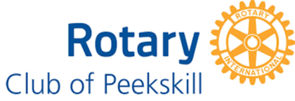
Dr. Robert J. Hales Scholarship
Awarded by the Rotary Club of Peekskill Foundation, Inc.
The Dr. Robert J. Hales Scholarship was created in memory of Dr. Hales’ nearly 50 years of dedicated service to the Peekskill and Cortlandt communities. During his more than 46 years as a member of the Rotary Club of Peekskill, he served as club president, never missed a weekly meeting, held many other leadership positions, and earned respect as the primary mentor to all club leaders who followed him. During his four decades of dental practice in Peekskill, Dr. Hales also was a member of the Cortlandt Hook & Ladder Fire Department; the Cortlandt Yacht Club; the Shattemuc Yacht Club; the Lincoln Society and board member of the Lincoln Depot Museum. Throughout his life, Dr. Hales epitomized the values behind Rotary’s motto of Service Above Self.
This scholarship is designed to recognize students who achieved academic excellence and who demonstrate a similar passion as did Dr. Hales for science for service to community, school and family. The scholarship of $1,000 will be given to a student who will continue academics in the fields of physics, chemistry, biology research or pre-medical.
.
Eligibility Requirements
- Current graduating senior of Peekskill High School, Hendrick Hudson High School or Walter Panas High School.
- Minimum cumulative grade point average of 2.5 on a 4.0 scale
- Enrollment in a four-year college or university as a full-time student
- Demonstrated commitment of service to community, school and family.

Required Application Documents
Applicants are required to submit the following application documents:
- Student’s name, address, phone contact and email
- High school enrollment and current grades transcript
- Statement of reasons for consideration
- Letter of acceptance from an institution of higher learning
- At least 2 letters of recommendation from faculty, counselors or other professionals

Applications are due by April 22, 2023 and should be mailed to:
Dr. Robert J. Hales Scholarship
Attn: Dr. Donald Feldman
1124 Main Street
Peekskill, NY 10566

